Dated 10-02-2024

Hosting a static website using S3

<https://catalog.us-east-1.prod.workshops.aws/workshops/f3a3e2bd-e1d5-49de-b8e6-dac361842e76/en-US/basic-modules/60-s3/s3/1-s3>

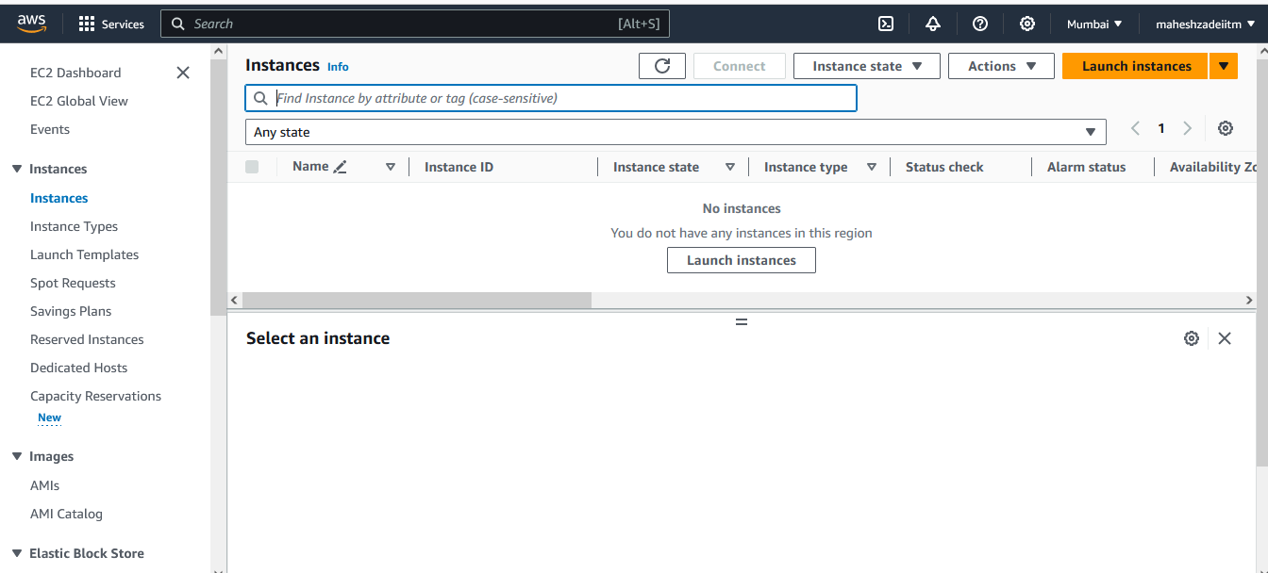

Create two EC2 instances using below user data

---------------------------------------------------------------------------------------------------------------------------------------

#!/bin/sh

​

#Install a LAMP stack

dnf install -y httpd wget php-fpm php-mysqli php-json php php-devel

dnf install -y mariadb105-server

dnf install -y httpd php-mbstring

​

#Start the web server

chkconfig httpd on

systemctl start httpd

​

#Install the web pages for our lab

if [ ! -f /var/www/html/immersion-day-app-php7.zip ]; then

cd /var/www/html

wget -O 'immersion-day-app-php7.zip' 'https://static.us-east-1.prod.workshops.aws/public/88a8dca7-a449-45ef-8175-384d9646aea5/assets/immersion-day-app-php7.zip'

unzip immersion-day-app-php7.zip

fi

​

#Install the AWS SDK for PHP

if [ ! -f /var/www/html/aws.zip ]; then

cd /var/www/html

mkdir vendor

cd vendor

wget https://docs.aws.amazon.com/aws-sdk-php/v3/download/aws.zip

unzip aws.zip

fi

​

# Update existing packages

dnf update -y

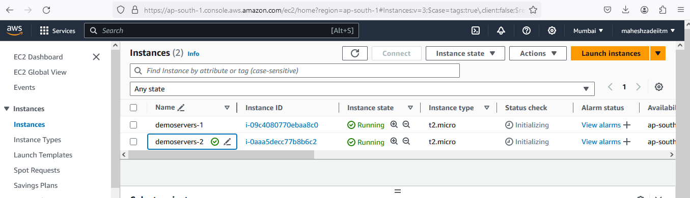

Copy the public IP in both the servers and paste in browser for the website

Pls make a note of availability Zone

Now launch a Load Balancer

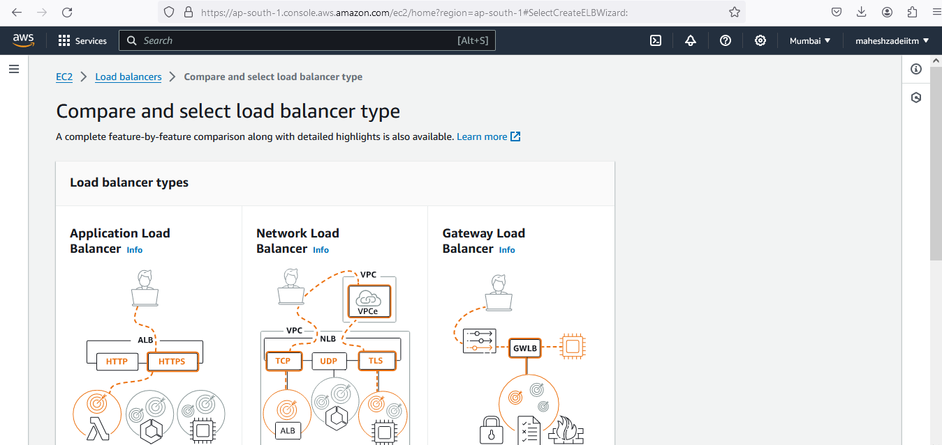

Click on application load Balancer

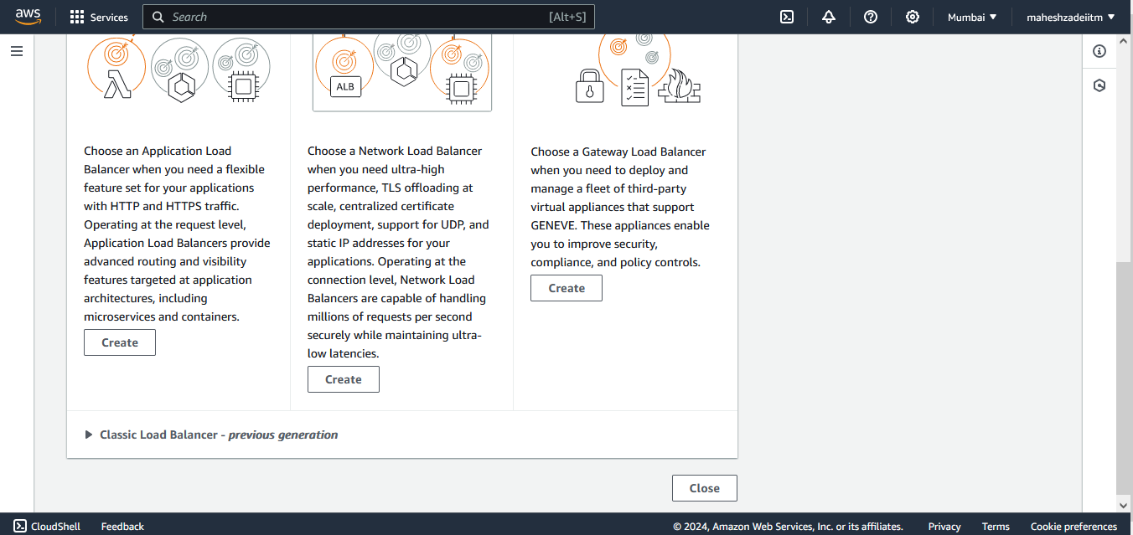

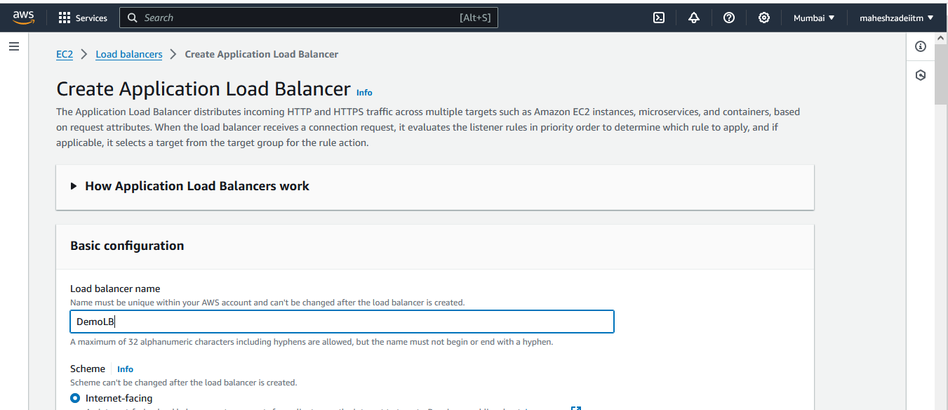

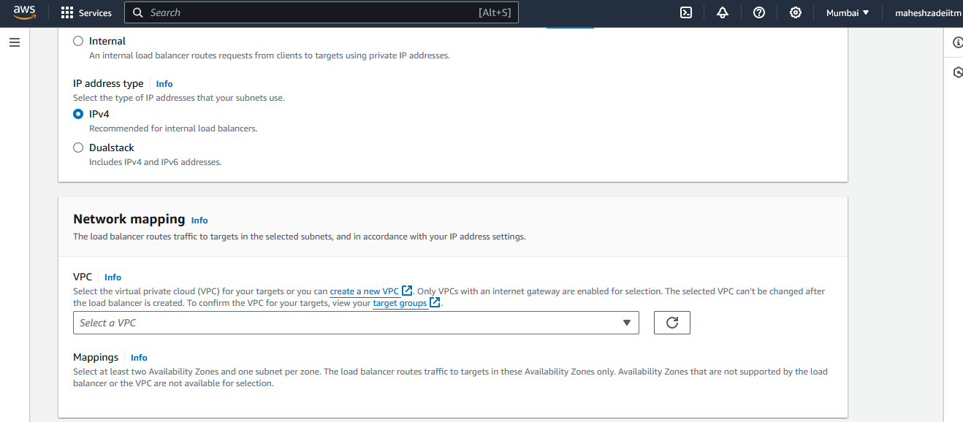

Select IPv4

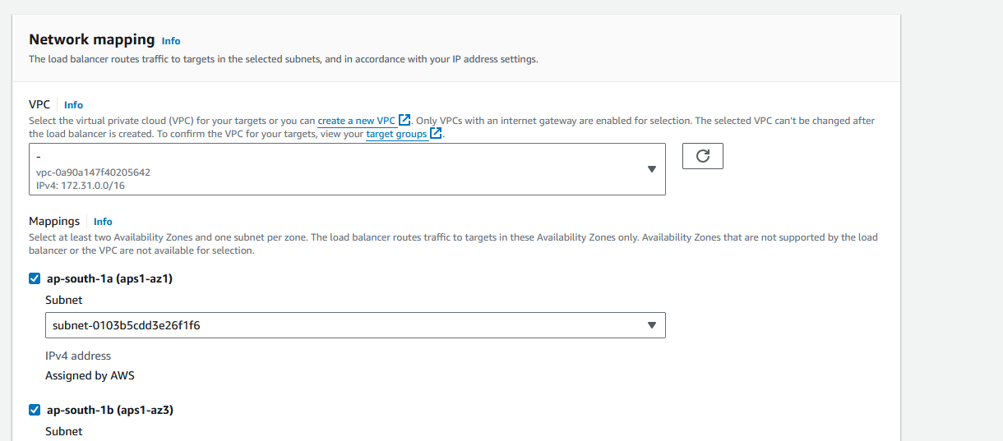

Create New Security Group

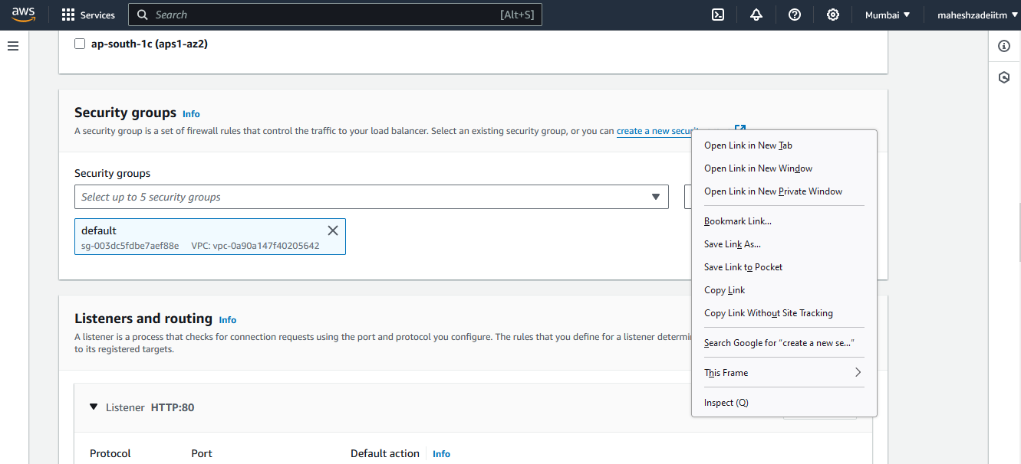

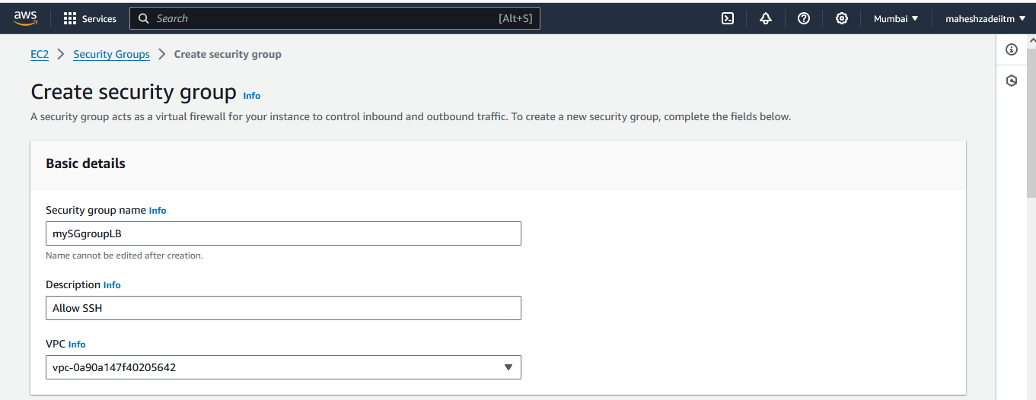

Add inbound rule

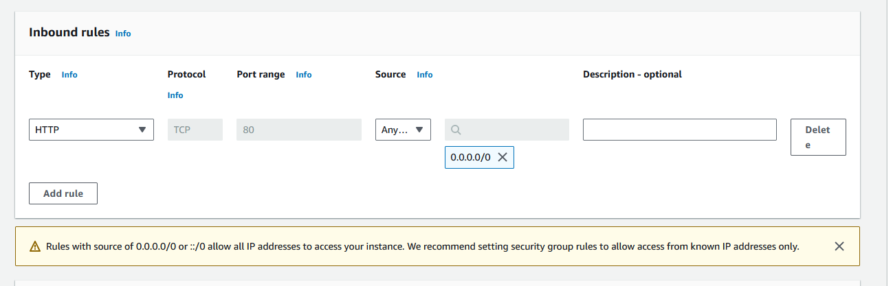

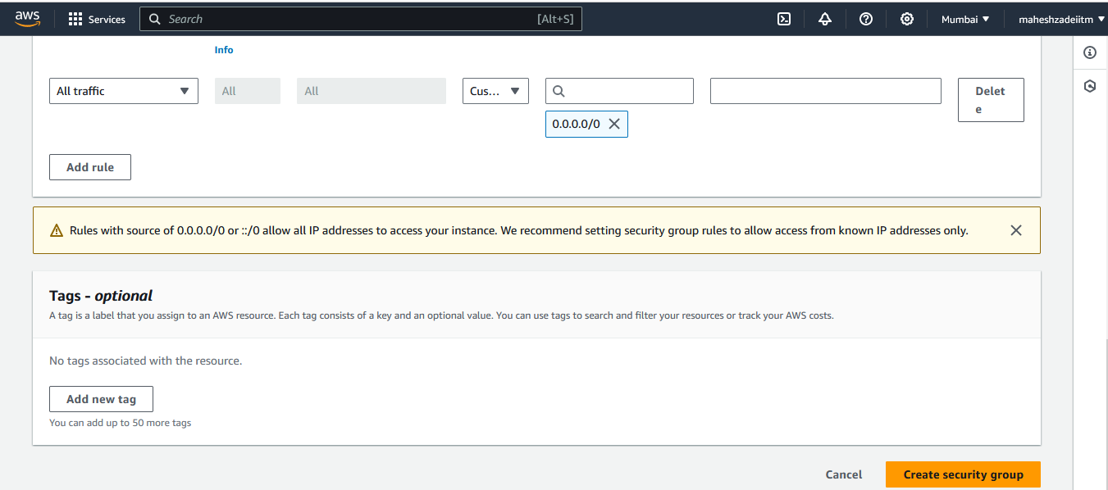

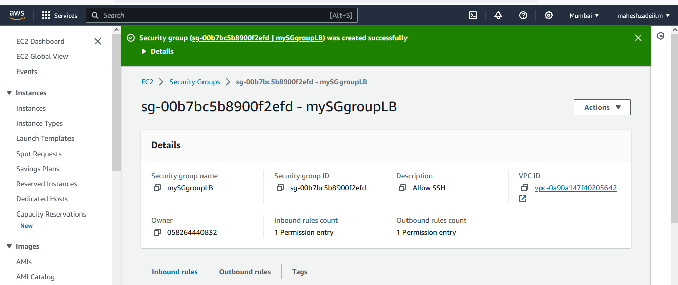

Select Secuiry Group in Load Balancer and refresh

Create Target Group

Click on include

Click on create toarget group

Go to load Balancer

Now create new Bucket

Desable and Click

Click on create bucket

Create a folder S3 Static web site hosting or any and copy the file

Copy this content from html file

Pls replace in purple colour address

Now upload the AWS.png in the bucket

Copy the image url and paste in html file

<https://demo-static-website-hosting-13-02-2024.s3.ap-south-1.amazonaws.com/aws.png>

Go to load Balancer now

Now Load Balancer showing Active

Copy DNS of load balancer

Paste DNS in browser

Now copy load balancer DNS in index.html file and save it

DemoLB-1294487803.ap-south-1.elb.amazonaws.com

Now upload the new index.html file

Pls select both the file and go to action and make it public using ACL

Paste the url of index.html in browser

Copy the url of image file in S3 bucket and paste in browser

Now we have launched the static website using s3 bucket .